**LAB -3**

**TASK -1**

**CODING :**

using System;

using System.Collections.Generic;

using System.Linq;

using System.Text;

namespace ali1234213

{

public class book

{

public string title;

public string author;

public int yearpublished;

public int numberofpages;

public char covertype;}

class Program

{

static void Main(string[] args)

{

var first = new book();

first.title = "Robert Lafore";

first.author = "floyd";

first.yearpublished = 1986;

first.numberofpages = 85;

first.covertype = 'A';

Console.WriteLine("Book Characteristics");

Console.WriteLine("Title : {0}", first.title);

Console.WriteLine("Author : {0}", first.author);

Console.WriteLine("Year : {0}", first.yearpublished);

Console.WriteLine("Number of Pages : {0}", first.numberofpages);

Console.WriteLine("Cover Type : {0}", first.covertype);

Console.ReadKey();}

}}

**OUTPUT :**

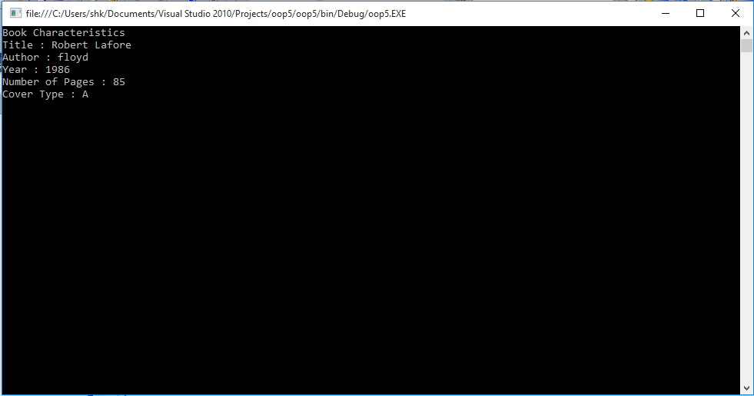

**TASK -2**

**CODING :**

using System;

using System.Collections.Generic;

using System.Linq;

using System.Text;

namespace ali1234213

{

public class book

{

//task1;

public string title;

public string author;

public int yearpublished;

public int numberofpages;

public char covertype;

}

class Program

{

static void Main(string[] args)

{

var first = new book();

Console.Write("Enter Title of book : ");

first.title = Console.ReadLine();

Console.Write("Enter Author of book : ");

first.author = Console.ReadLine();

Console.Write("Enter Published Year : ");

first.yearpublished = Convert.ToInt32(Console.ReadLine());

Console.Write("Enter Number of pages : ");

first.numberofpages = Convert.ToInt32(Console.ReadLine());

Console.Write("Enter Cover type of Book : ");

first.covertype = Convert.ToChar(Console.ReadLine());

Console.WriteLine("Book Characteristics");

Console.WriteLine("Title : {0}", first.title);

Console.WriteLine("Author : {0}", first.author);

Console.WriteLine("Year : {0}", first.yearpublished);

Console.WriteLine("Number of Pages : {0}", first.numberofpages);

Console.WriteLine("Cover Type : {0}", first.covertype);

Console.ReadKey();

}

}

}

**OUTPUT :**

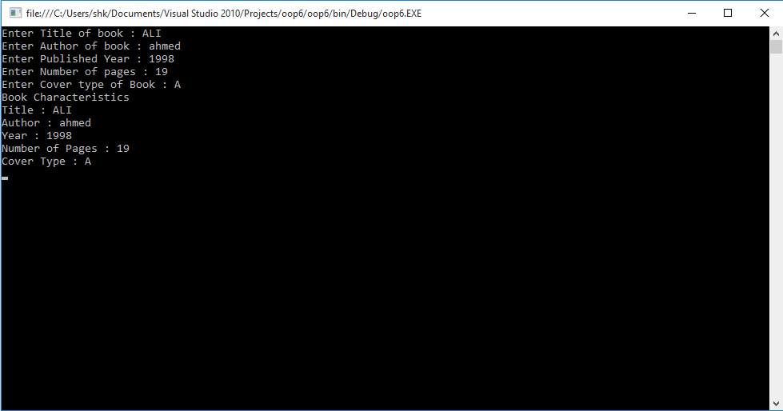

**TASK -3**

**CODING :**

using System;

using System.Collections.Generic;

using System.Linq;

using System.Text;

namespace oop7

{

public class student

{

public string name;

public float age;

public float Englishmarks;

public float mathmarks;

public float science;

public float totalmarks = 1;

public float obtainedmarks = 1;

public float percentage;

public float obt()

{

return

obtainedmarks = Englishmarks + mathmarks + science;

}

public float p()

{

return

percentage = (obtainedmarks * 100) / totalmarks;

}

}

class Program

{

static void Main(string[] args)

{

var first = new student();

float a = first.obt();

float b = first.p();

Console.WriteLine("Enter name :");

first.name = Console.ReadLine();

Console.WriteLine("Enter Age :");

first.age = Convert.ToInt32(Console.ReadLine());

Console.WriteLine("Enter Total marks :");

first.totalmarks = Convert.ToInt32(Console.ReadLine());

Console.WriteLine("Enter English marks :");

first.Englishmarks = Convert.ToInt32(Console.ReadLine());

Console.WriteLine("Enter Math marks :");

first.mathmarks = Convert.ToInt32(Console.ReadLine());

Console.WriteLine("Enter Science marks :");

first.science = Convert.ToInt32(Console.ReadLine());

Console.WriteLine("Student Info");

Console.WriteLine("Name : {0}", first.name);

Console.WriteLine("Age : {0}", first.age);

Console.WriteLine("English marks : {0}", first.Englishmarks);

Console.WriteLine("Math marks : {0}", first.mathmarks);

Console.WriteLine("Science marks : {0}", first.science);

Console.WriteLine("Obtained marks : {0}", first.obt());

Console.WriteLine("Total marks : {0}", first.totalmarks);

Console.WriteLine("Percentage : {0}", first.p());

Console.ReadKey();

}

}

}

**OUTPUT :**

